|  |  |
| --- | --- |
| Course Name | ITD 2313 – Script Programming |
| Instructor | Put instruction name here |
| Student Name | Put student name here |
| Due date | Put assignment due date here |
| Grade | Put grade earned here |
| Grading Comments | Put instructor comments here |

## Project # 5

### Special Instructions:

1. This project is to be done in a python program file. The file needs to be submitted as part of the submission for this assignment. Place the program file into the zip file that is submitted for this assignment.

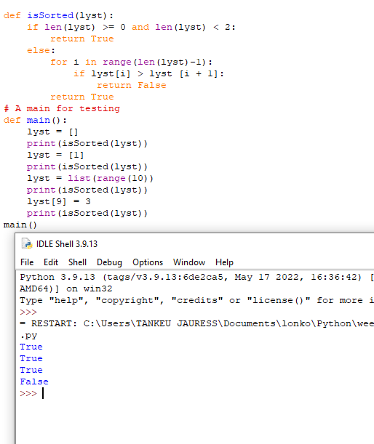

## Project # 8

### Special Instructions:

1. This project is to be done in a python program file. The file needs to be submitted as part of the submission for this assignment. Place the program file into the zip file that is submitted for this assignment.

This function work.

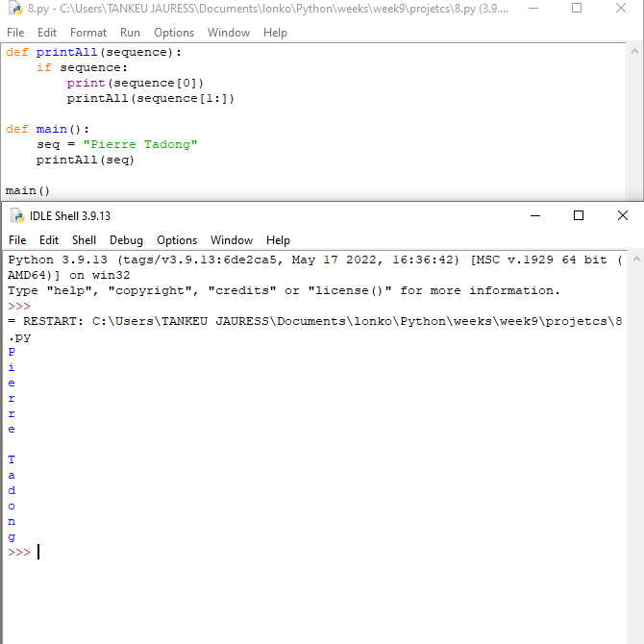

## Project # 9

### Special Instructions:

1. This project is to be done in a python program file. The file needs to be submitted as part of the submission for this assignment. Place the program file into the zip file that is submitted for this assignment.

